**实验报告**

# Registry仓库部分

将192.168.100.150registry仓库恢复到 刚安装docker的快照，重新创建registry仓库

docker pull registry:2

mkdir -p /v913/registry

docker run -itd --name registry -p5000:5000 --restart always -v /v913/registry/:/var/lib/registry registry:2

# swarm部分

返回到servera：

创建swarm和集群网络：

Servera：

docker swarm init --advertise-addr 192.168.100.100

serverb、c：

复制servera生成的这段黏贴到b、c让b、c加入到a集群中（这里复制自己的 别用我的）

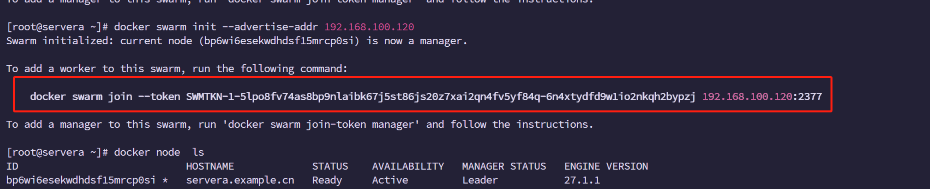

Servera创建lnmp网卡：

docker network create --driver overlay gmq_v913_lnmp_ovl --subnet 24.17.3.0/24 --gateway 24.17.3.254

# supermin部分

serverc使用supermin构建基准镜像：

yum -y install supermin

mkdir /tmp/supermin

cd /tmp/supermin/

基于这些软件包创建一个rocky9的系统环境

supermin -v --prepare yum coreutils iproute vim rpm httpd-tools -o supermin.d

supermin -v --build --format chroot supermin.d/ -o rocky9.d

cp /etc/resolv.conf rocky9.d/etc/

echo 9.4 > rocky9.d/etc/dnf/vars/releasever

导入证书文件

chroot rocky9.d/ /usr/bin/bash

rpm --import /etc/pki/rpm-gpg/RPM-GPG-KEY-Rocky-9

打包压缩并导入成镜像

exit

tar -cf rk9.tar -C rocky9.d/ .

docker import rk9.tar gmq:v913

docker tag gmq:v913 registry:5000/v913/gmq:v913

docker push registry:5000/v913/gmq:v913

serverc：

wget <https://nginx.org/download/nginx-1.26.2.tar.gz>

vim Dockerfile #写入内容：

FROM registry:5000/v913/gmq:v913

COPY nginx-1.26.2.tar.gz /

RUN yum -y install tar httpd-tools gcc-c++ openssl-devel zlib-devel pcre-devel tar && cd / && tar -zxvf nginx-1.26.2.tar.gz && cd nginx-1.26.2 && ./configure --prefix=/usr/local/gmq --sbin-path=/usr/sbin/gmq --conf-path=/etc/nginx/nginx.conf --with-http_ssl_module --with-http_stub_status_module && make && make install && cd / && rm -rf nginx* && echo defaults_page by gmq > /usr/local/gmq/html/index.html

RUN ln -s /usr/sbin/gmq /usr/bin/nginx

RUN groupadd gmq && useradd -g gmq gmq

RUN chown -R gmq:gmq /usr/local/gmq /usr/sbin/gmq /etc/nginx

RUN mkdir /www && echo "v1.0 27.1.1" > /www/index.html

USER gmq

EXPOSE 80/tcp

CMD ["/usr/sbin/gmq","-g","daemon off;"]

docker build -t gmq:nginx .

docker tag gmq:nginx registry:5000/v913/gmq:nginx

docker push registry:5000/v913/gmq:nginx

~~serverc：~~

~~openssl genrsa -out /file.key 2048~~

~~openssl req -new -key /file.key -out /file.csr -days 365~~

~~openssl x509 -req -in /file.csr -signkey /file.key -out /file.crt -days 365~~

Vim Dockerfile1 写入:

FROM registry:5000/v913/gmq:nginx

RUN echo "i'am front" > /usr/local/gmq/html/index.html

RUN mkdir /usr/local/gmq/html/cn_name

RUN echo "耿铭琦" > /usr/local/gmq/html/cn_name/index.html

RUN mkdir /usr/local/gmq/html/en_name

RUN echo "gengmingqi" > /usr/local/gmq/html/en_name/index.html

RUN mkdir /usr/local/gmq/html/you

RUN echo "rhca2013" > /usr/local/gmq/html/you/index.html

RUN echo "FILE_UNKNOWN" > /usr/local/gmq/html/404.html

RUN mkdir /usr/local/gmq/html/Privatewebsite

RUN htpasswd -bc /etc/nginx/.htpasswd gmq gmq

RUN echo "access" > /usr/local/gmq/html/Privatewebsite/index.html

RUN mkdir /usr/local/gmq/html/ssl

RUN echo "Running on 443 port" > /usr/local/gmq/html/ssl/index.html

COPY nginx.conf /etc/nginx/nginx.conf

docker build -t gmq:front . -f Dockerfile1

docker tag gmq:front registry:5000/v913/gmq:front

docker push registry:5000/v913/gmq:front

Vim Dockerfile2 写入:

FROM registry:5000/v913/gmq:nginx

RUN echo "i'am backend v1.0" > /usr/local/gmqhtml/index.html

RUN mkdir /usr/local/gmqhtml/exam

RUN echo "v1.0 by 胡智瀚" > /usr/local/gmq/html/exam/index.html

COPY v1.0.conf /etc/nginx/nginx.conf

docker build -t gmq:backend_v1.0 . -f Dockerfile2

Vim Dockerfile3 写入:

FROM registry:5000/v913/gmq:nginx

RUN echo "i'am backend v2.0" > /usr/local/gmq/html/index.html

RUN mkdir /usr/local/gmq/html/exam

RUN echo "v2.0 by 胡智瀚" > /usr/local/gmq/html/exam/index.html

RUN echo "v2.0 27.1.1" > /www/index.html

COPY v1.0.conf /etc/nginx/nginx.conf

docker build -t gmq:backend_v2.0 . -f Dockerfile3

回到集群的管理节点servera 创建服务service

Servera:

docker service create --name front_srv --replicas 3 --network gmq_v913_lnmp_ovl -p 80:80 -p 443:443 registry:5000/v913/gmq:front

vim /etc/hosts

验证：

第8要求：版本回滚

没做 好困-.-