# **Prometheus告警媒介 钉钉**

# **一、创建钉钉群**

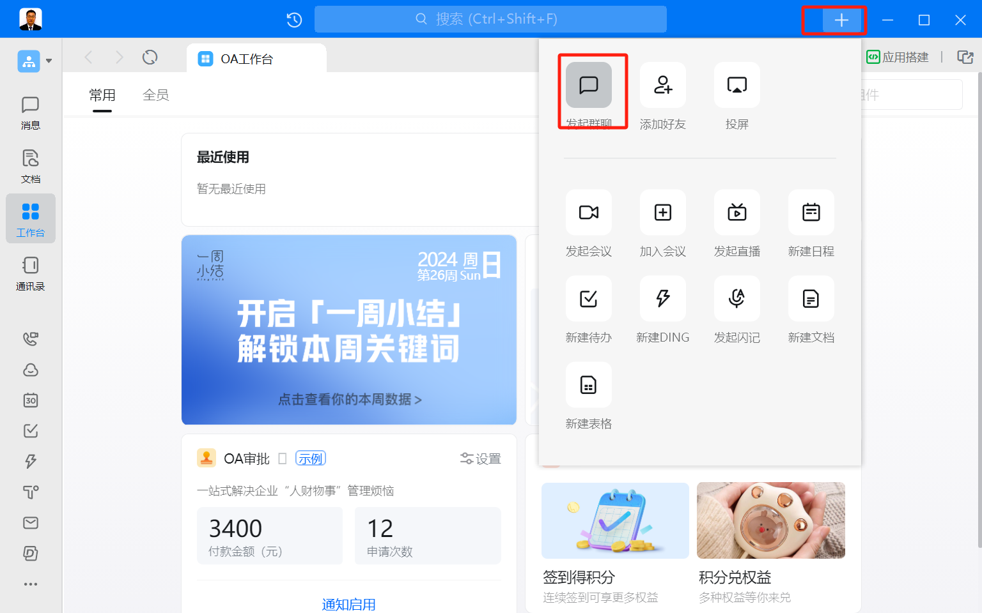

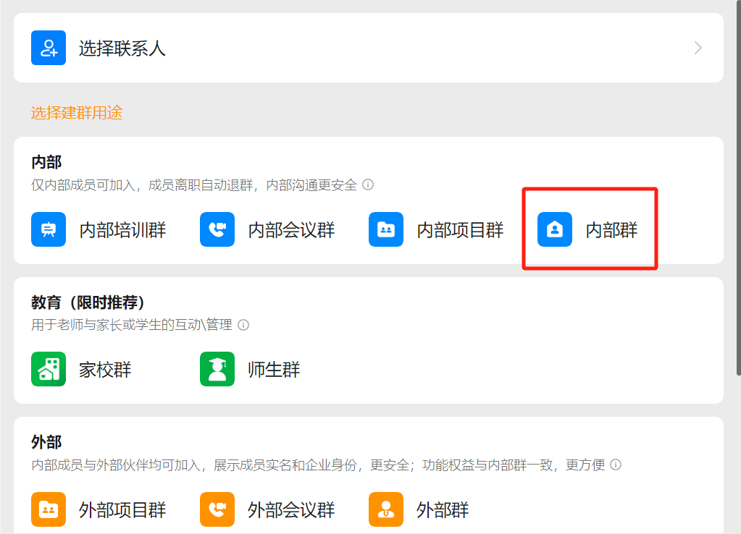

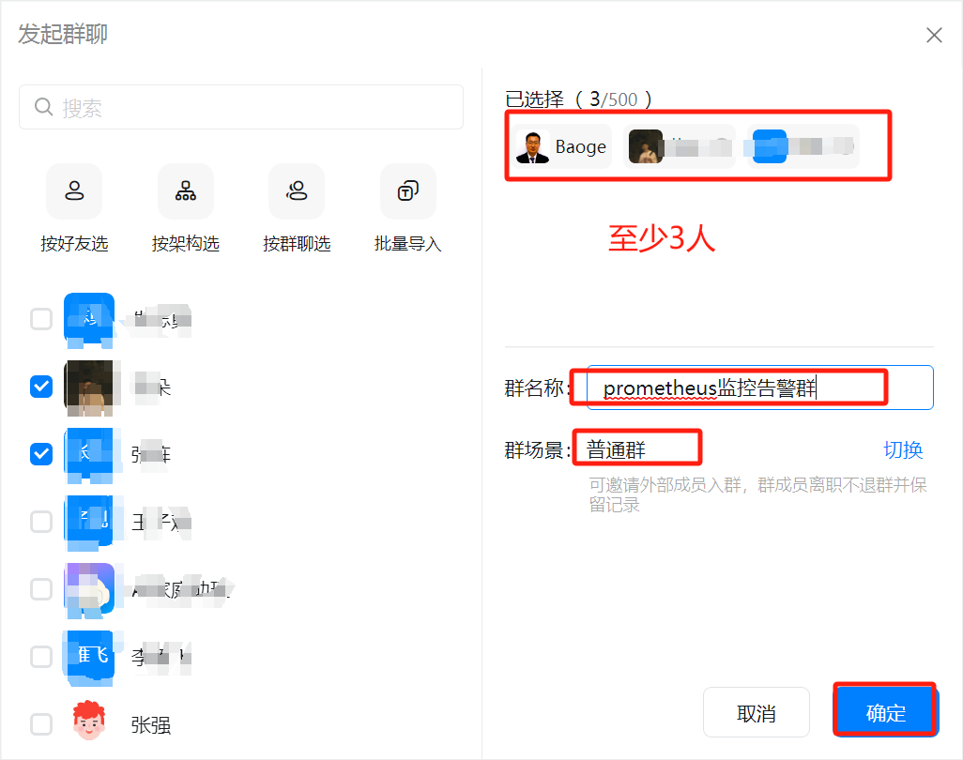

# **二、添加钉钉群机器人**

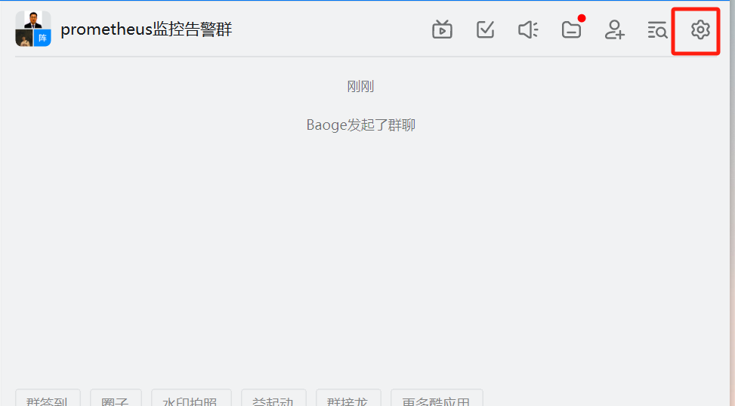

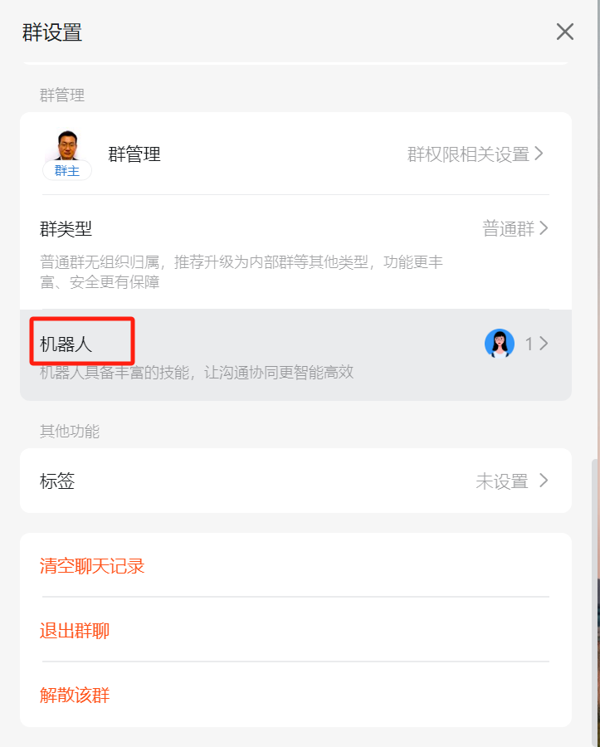

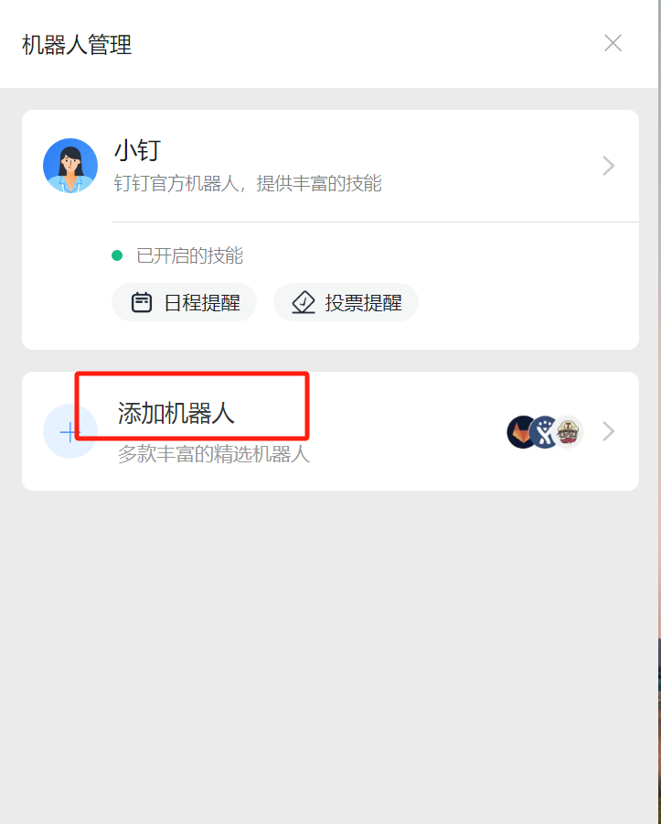

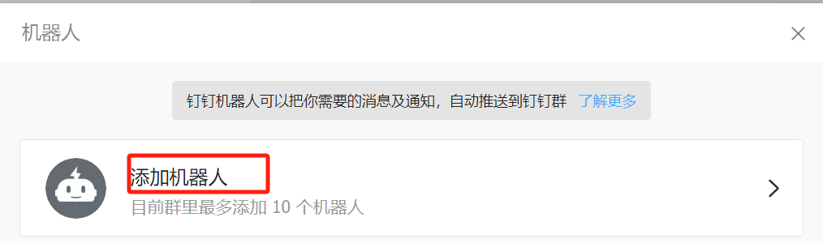

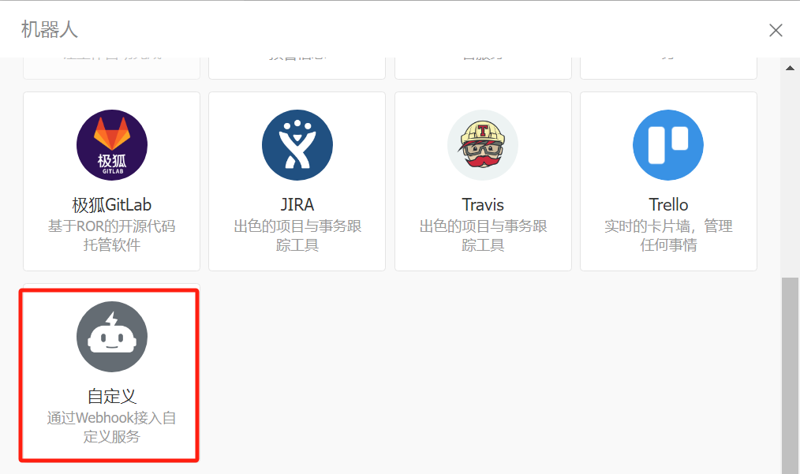

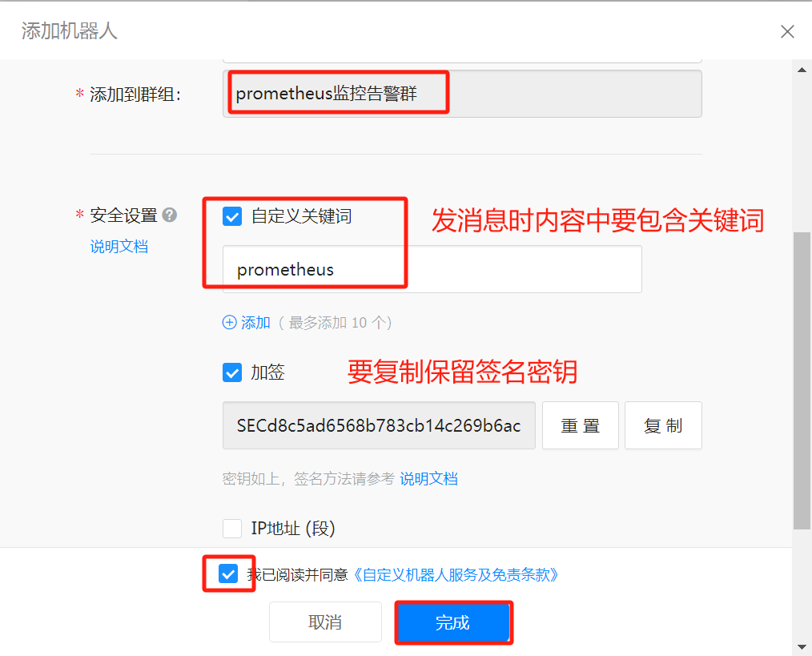

secret: SECd8c5ad6568b783cb14c269b6ac823a0cf5601ccbf9b20516f7b5b75b8f4c54e6

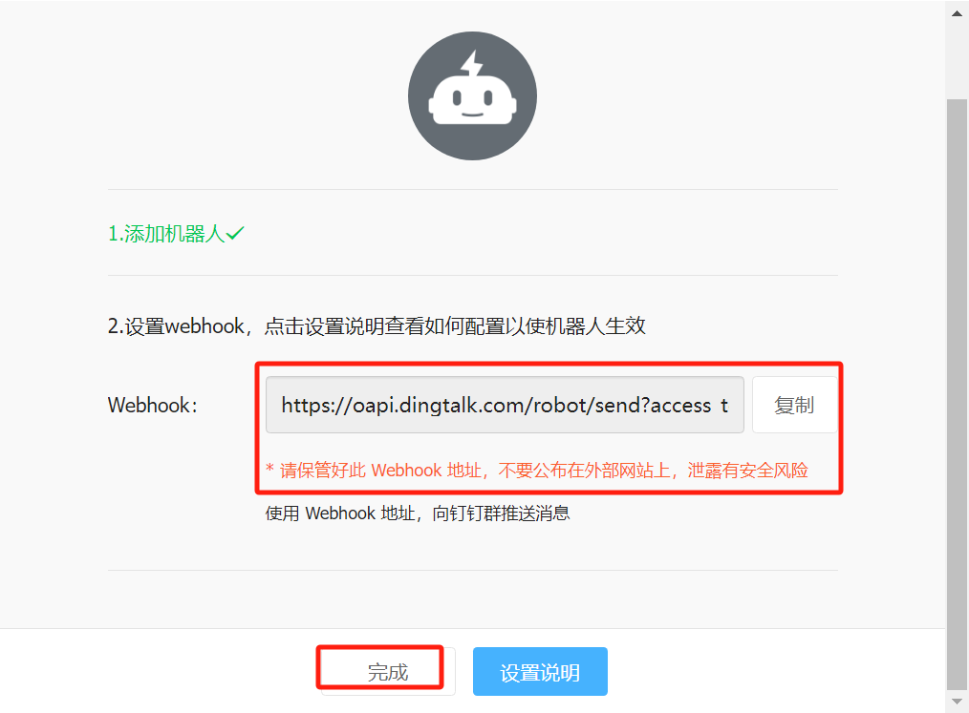

Webhook：https://oapi.dingtalk.com/robot/send?access_token=25a0f1179f324922658e6ddc47588da73f8b6273558a1e633adbf8475ba1cdbb

# **三、安装钉钉告警插件**

[root@alertmanager ~]# wget https://github.com/timonwong/prometheus-webhook-dingtalk/releases/download/v2.1.0/prometheus-webhook-dingtalk-2.1.0.linux-amd64.tar.gz

[root@alertmanager ~]# ls  
prometheus-webhook-dingtalk-2.1.0.linux-amd64.tar.gz

[root@alertmanager ~]# tar xf prometheus-webhook-dingtalk-2.1.0.linux-amd64.tar.gz  
[root@alertmanager ~]# ls  
prometheus-webhook-dingtalk-2.1.0.linux-amd64

[root@alertmanager ~]# mv prometheus-webhook-dingtalk-2.1.0.linux-amd64 /usr/local/prometheus-webhook-dingtalk

[root@alertmanager ~]# ls /usr/local/  
alertmanager prometheus-webhook-dingtalk

[root@alertmanager ~]# mv /usr/local/prometheus-webhook-dingtalk/config.example.yml /usr/local/prometheus-webhook-dingtalk/config.yml  
[root@alertmanager ~]# ls /usr/local/prometheus-webhook-dingtalk/  
config.yml contrib LICENSE prometheus-webhook-dingtalk

注册为系统服务  
[root@alertmanager prometheus-webhook-dingtalk]# cat > /usr/lib/systemd/system/prometheus-webhook-dingtalk.service << EOF  
[Service]  
ExecStart=/usr/local/prometheus-webhook-dingtalk/prometheus-webhook-dingtalk --config.file=/usr/local/prometheus-webhook-dingtalk/config.yml  
   
[Install]  
WantedBy=multi-user.target  
   
[Unit]  
Description=prometheus-webhook-dingtalk  
After=network.target  
EOF

重载/开机自启/查看状态/启动  
[root@alertmanager prometheus-webhook-dingtalk]# systemctl daemon-reload  
[root@alertmanager prometheus-webhook-dingtalk]# systemctl enable prometheus-webhook-dingtalk  
[root@alertmanager prometheus-webhook-dingtalk]# systemctl start prometheus-webhook-dingtalk

[root@alertmanager prometheus-webhook-dingtalk]# systemctl status prometheus-webhook-dingtalk

# **四、配置钉钉告警插件与钉钉机器人集成**

[root@alertmanager ~]# cd /usr/local/prometheus-webhook-dingtalk/  
[root@alertmanager prometheus-webhook-dingtalk]# pwd  
/usr/local/prometheus-webhook-dingtalk  
[root@alertmanager prometheus-webhook-dingtalk]# ls  
config.yml contrib LICENSE prometheus-webhook-dingtalk

[root@alertmanager prometheus-webhook-dingtalk]# vim config.yml  
[root@alertmanager prometheus-webhook-dingtalk]# cat config.yml  
templates:

- /usr/local/alertmanager/dingtalk.tmpl #自定义告警模板文件及位置

targets:

webhook1:

url: https://oapi.dingtalk.com/robot/send?access_token=25a0f1179f324922658e6ddc47588da73f8b6273558a1e633adbf8475ba1cdbb

secret: SECd8c5ad6568b783cb14c269b6ac823a0cf5601ccbf9b20516f7b5b75b8f4c54e6

message:

title: '{{ template "ops.title" . }}' # 添加模板标题，在下面的模板文件title位置

text: '{{ template "ops.content" . }}' # 添加模板内容，在下面的模板文件content位置

说明：  
templates:  
 - /usr/local/alertmanager/dingtalk.tmpl 自定义告警模板文件及位置  
targets:  
 webhook1:  
 url: https://oapi.dingtalk.com/robot/send?access_token=e7f8aac8fc2705064b28ae1b6d1a6d0dfc53974e0dc98423384b637c9ebe4498 # 配置钉钉机器人webhook_url

secret: SECc95134129e043e4be06df4d5aa2afdef066a6d361ac73da97bc7220618cfa9da 配置加签SECRET  
 message:  
 title: '{{ template "ops.title" . }}' # 添加模板标题，在下面的模板文件title位置  
 text: '{{ template "ops.content" . }}' # 添加模板内容，在下面的模板文件content位置

# **五、为alertmanager配置告警模板文件**

[root@alertmanager ~]# vim /usr/local/alertmanager/dingtalk.tmpl  
[root@alertmanager ~]# cat /usr/local/alertmanager/dingtalk.tmpl  
{{ define "__subject" }}  
[{{ .Status | toUpper }}{{ if eq .Status "firing" }}:{{ .Alerts.Firing | len }}{{ end }}]  
{{ end }}  
  
  
{{ define "__alert_list" }}{{ range . }}  
---  
 **prometheus告警类型**: {{ .Labels.alertname }}  
 **prometheus告警级别**: {{ .Labels.level }}  
 **prometheus故障主机**: {{ .Labels.instance }}  
 **prometheus告警信息**: {{ .Annotations.description }}  
 **prometheus触发时间**: {{ (.StartsAt.Add 28800e9).Format "2006-01-02 15:04:05" }}  
{{ end }}{{ end }}  
  
{{ define "__resolved_list" }}{{ range . }}  
---  
 **prometheus告警类型**: {{ .Labels.alertname }}  
 **prometheus告警级别**: {{ .Labels.level }}  
 **prometheus故障主机**: {{ .Labels.instance }}  
 **prometheus触发时间**: {{ (.StartsAt.Add 28800e9).Format "2006-01-02 15:04:05" }}  
 **prometheus恢复时间**: {{ (.EndsAt.Add 28800e9).Format "2006-01-02 15:04:05" }}  
{{ end }}{{ end }}  
  
  
{{ define "ops.title" }}  
{{ template "__subject" . }}  
{{ end }}  
  
{{ define "ops.content" }}  
{{ if gt (len .Alerts.Firing) 0 }}  
**====prometheus 侦测到{{ .Alerts.Firing | len }}个故障====**  
{{ template "__alert_list" .Alerts.Firing }}  
---  
{{ end }}  
  
{{ if gt (len .Alerts.Resolved) 0 }}  
**====prometheus 恢复{{ .Alerts.Resolved | len }}个故障====**  
{{ template "__resolved_list" .Alerts.Resolved }}  
{{ end }}  
{{ end }}  
  
{{ define "ops.link.title" }}{{ template "ops.title" . }}{{ end }}  
{{ define "ops.link.content" }}{{ template "ops.content" . }}{{ end }}  
{{ template "ops.title" . }}  
{{ template "ops.content" . }}

# **六、修改Alertmanager配置文件添加钉钉告警渠道**

[root@alertmanager ~]# ss -anput | grep ":8060"  
tcp LISTEN 0 4096 [::]:8060 [::]:* users:(("prometheus-webh",pid=9313,fd=3))

[root@alertmanager ~]# vim /usr/local/alertmanager/alertmanager.yml  
[root@alertmanager ~]# cat /usr/local/alertmanager/alertmanager.yml  
global:  
 resolve_timeout: 3m  
  
templates:  
 - '/usr/local/alertmanager/dingtalk.tmpl'  
  
route:  
 group_by: ['env','instance','type','group','job','alertname']  
 group_wait: 30s  
 group_interval: 5m  
 repeat_interval: 1h  
 receiver: dingtalk_webhook  
  
receivers:  
- name: 'dingtalk_webhook'  
 webhook_configs:  
 - url: 'http://192.168.10.17:8060/dingtalk/webhook1/send'  
 send_resolved: true

说明如下：  
global:  
 resolve_timeout: 3m 定义持续多长时间未接收到告警标记后，就将告警状态标记为已解决  
  
templates:  
 - '/usr/local/alertmanager/dingtalk.tmpl' 告警模板位置  
  
route:  
 group_by: ['env','instance','type','group','job','alertname'] 根据告警规则组名进行分组  
 group_wait: 30s 分组内第一个告警等待时间，30s内如有第二个告警会合并一个告警  
 group_interval: 5m 发送新告警间隔时间  
 repeat_interval: 1h 重复告警间隔发送时间，如果没处理过1h再次发送  
 receiver: dingtalk_webhook 告警接收人  
  
receivers:  
- name: 'dingtalk_webhook' 告警接收人  
 webhook_configs:  
 - url: 'http://192.168.10.17:8060/dingtalk/webhook1/send' 访问webhook1 url  
 send_resolved: true 在恢复后是否发送恢复消息给接收人

# **七、重启prometheus-webhook-dingtalk及alertmanager**

[root@alertmanager ~]# systemctl restart prometheus-webhook-dingtalk

[root@alertmanager ~]# systemctl restart alertmanager

# **八、告警测试**

[root@prometheus-server ~]# df -h  
文件系统 容量 已用 可用 已用% 挂载点  
devtmpfs 1.9G 0 1.9G 0% /dev  
tmpfs 2.0G 0 2.0G 0% /dev/shm  
tmpfs 2.0G 9.8M 1.9G 1% /run  
tmpfs 2.0G 0 2.0G 0% /sys/fs/cgroup  
/dev/mapper/centos-root 50G 7.5G 43G 15% /  
/dev/sda1 1014M 293M 722M 29% /boot  
/dev/mapper/centos-home 969G 33M 969G 1% /home  
tmpfs 391M 12K 391M 1% /run/user/42  
tmpfs 391M 0 391M 0% /run/user/0  
  
  
[root@prometheus-server ~]# dd if=/dev/zero of=/test1 bs=1M count=20000  
记录了10000+0 的读入  
记录了10000+0 的写出  
10485760000字节(10 GB)已复制，14.1928 秒，739 MB/秒  
  
  
[root@prometheus-server ~]# df -hT

文件系统 类型 容量 已用 可用 已用% 挂载点

devtmpfs devtmpfs 898M 0 898M 0% /dev

tmpfs tmpfs 910M 0 910M 0% /dev/shm

tmpfs tmpfs 910M 9.7M 901M 2% /run

tmpfs tmpfs 910M 0 910M 0% /sys/fs/cgroup

/dev/mapper/centos-root xfs 50G 22G 29G 43% /

/dev/mapper/centos-home xfs 47G 33M 47G 1% /home

/dev/sda1 xfs 1014M 151M 864M 15% /boot

tmpfs tmpfs 182M 0 182M 0% /run/user/0

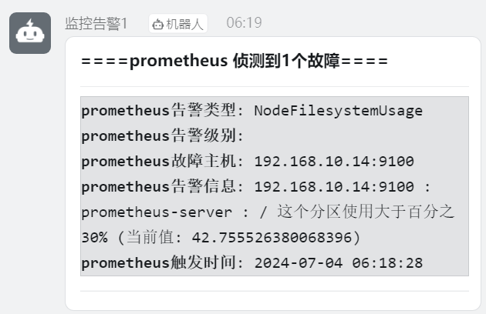

[root@prometheus-server ~]# rm -rf /test

[root@prometheus-server ~]# df -hT

文件系统 类型 容量 已用 可用 已用% 挂载点

devtmpfs devtmpfs 898M 0 898M 0% /dev

tmpfs tmpfs 910M 0 910M 0% /dev/shm

tmpfs tmpfs 910M 9.7M 901M 2% /run

tmpfs tmpfs 910M 0 910M 0% /sys/fs/cgroup

/dev/mapper/centos-root xfs 50G 1.9G 49G 4% /

/dev/mapper/centos-home xfs 47G 33M 47G 1% /home

/dev/sda1 xfs 1014M 151M 864M 15% /boot

tmpfs tmpfs 182M 0 182M 0% /run/user/0

