# **Prometheus安装及使用（二进制方式）**

# 一、Prometheus简介

## 1.Prometheus是什么

Prometheus是一个开源系统监控和警报工具，最初由 SoundCloud创建。自 2012 年以来，许多公司和组织都采用了 Prometheus，该项目拥有非常活跃的开发者和用户社区。

它现在是一个独立的开源项目，独立于任何公司进行维护。为了强调这一点，并明确项目的治理结构，Prometheus 于 2016 年作为继Kubernetes之后的第二个托管项目加入了云原生计算基金会（CNCF）。

## 2.Prometheus官方网址

<https://prometheus.io/docs/introduction/overview/>

# 二、Prometheus安装环境准备

Linux主机操作系统为：CentOS7u9

| 序号 | 主机名 | 主机IP地址 | 角色 | 硬件要求 |
| --- | --- | --- | --- | --- |
| 1 | prometheus-server | 192.168.10.14/24 | server | 2c2G |
| 2 | prometheus-agent | 192.168.10.15/24 | agent | 2c2G |
| 3 | grafana | 192.168.10.16/24 | grafana | 2c2G |
| 4 | alertmanager | 192.168.10.17/24 | alertmanager | 2c2G |

# 三、Prometheus安装

## 3.1 Prometheus server获取

[root@prometheus-server ~]# wget https://github.com/prometheus/prometheus/releases/download/v2.37.8/prometheus-2.37.8.linux-amd64.tar.gz

## 3.2 Prometheus安装

[root@prometheus-server ~]# tar xf prometheus-2.37.8.linux-amd64.tar.gz

[root@prometheus-server ~]# mv prometheus-2.37.8.linux-amd64 /usr/local/prometheus

## 3.3 Prometheus启动

### 3.3.1 修改Prometheus配置文件

[root@prometheus-server ~]# cd /usr/local/prometheus/  
[root@prometheus-server prometheus]# ls  
console_libraries consoles LICENSE NOTICE prometheus prometheus.yml promtool  
[root@prometheus-server prometheus]# vim prometheus.yml

。。。

static_configs:  
 - targets: ["192.168.10.14:9090"] 把localhost修改为192.168.10.14

。。。

### 3.3.2 启动Prometheus

[root@prometheus-server prometheus]# nohup ./prometheus --config.file=prometheus.yml &

[root@prometheus-server prometheus]# ps aux | grep prometheus  
root 29940 0.6 1.6 791544 67268 pts/1 Sl 19:31 0:00 ./prometheus --config.file=prometheus.yml

[root@prometheus-server prometheus]# ss -anput | grep ":9090"  
tcp ESTAB 0 0 192.168.10.14:50856 192.168.10.14:9090 users:(("prometheus",pid=29940,fd=10))  
tcp LISTEN 0 4096 [::]:9090 [::]:* users:(("prometheus",pid=29940,fd=7))  
tcp ESTAB 0 0 [::ffff:192.168.10.14]:9090 [::ffff:192.168.10.14]:50856 users:(("prometheus",pid=29940,fd=11))

可以把Prometheus托管给systemd，如下所示：

[root@prometheus-server prometheus]# pkill prometheus

注册为系统服务  
[root@prometheus-server prometheus]# cat > /usr/lib/systemd/system/prometheus.service << EOF  
[Service]  
ExecStart=/usr/local/prometheus/prometheus --config.file=/usr/local/prometheus/prometheus.yml  
   
[Install]  
WantedBy=multi-user.target  
   
[Unit]  
Description=prometheus  
After=network.target  
EOF

重载/开机自启/查看状态/启动  
[root@prometheus-server prometheus]# systemctl daemon-reload  
[root@prometheus-server prometheus]# systemctl enable prometheus  
[root@prometheus-server prometheus]# systemctl start prometheus

[root@prometheus-server prometheus]# systemctl status prometheus

[root@prometheus-server prometheus]# lsof -i:9090  
[root@prometheus-server prometheus]# ps -ef | grep prometheus

# 四、Prometheus UI界面访问

可以通过运行Prometheus server节点IP+9090端口对Prometheus进行访问。

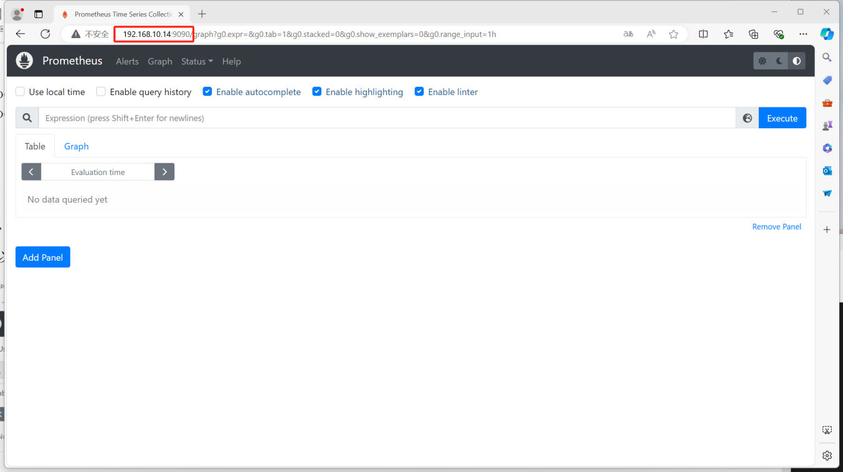

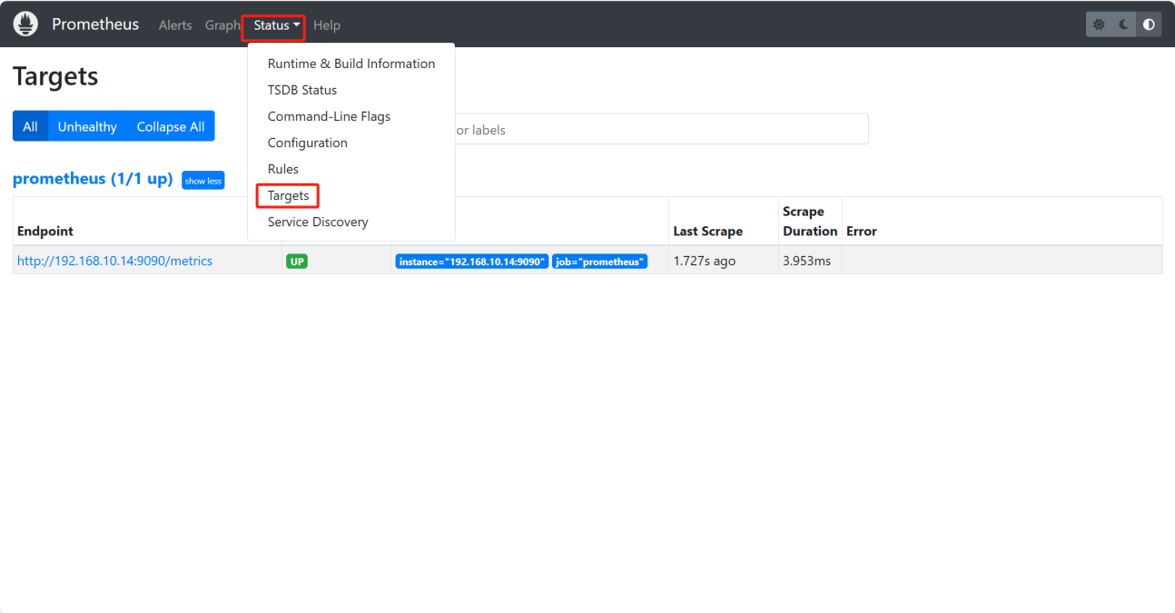

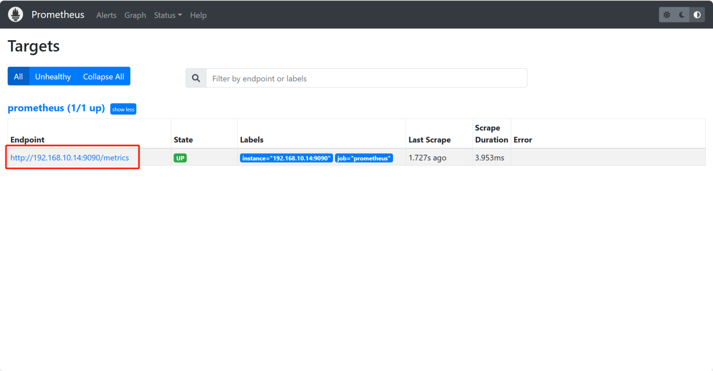

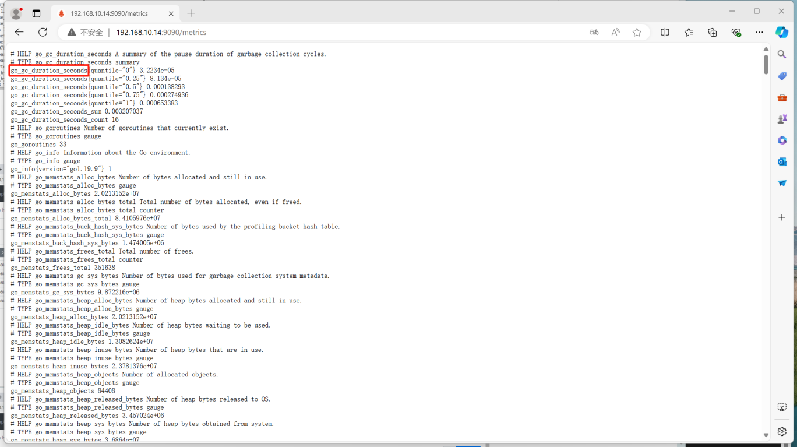

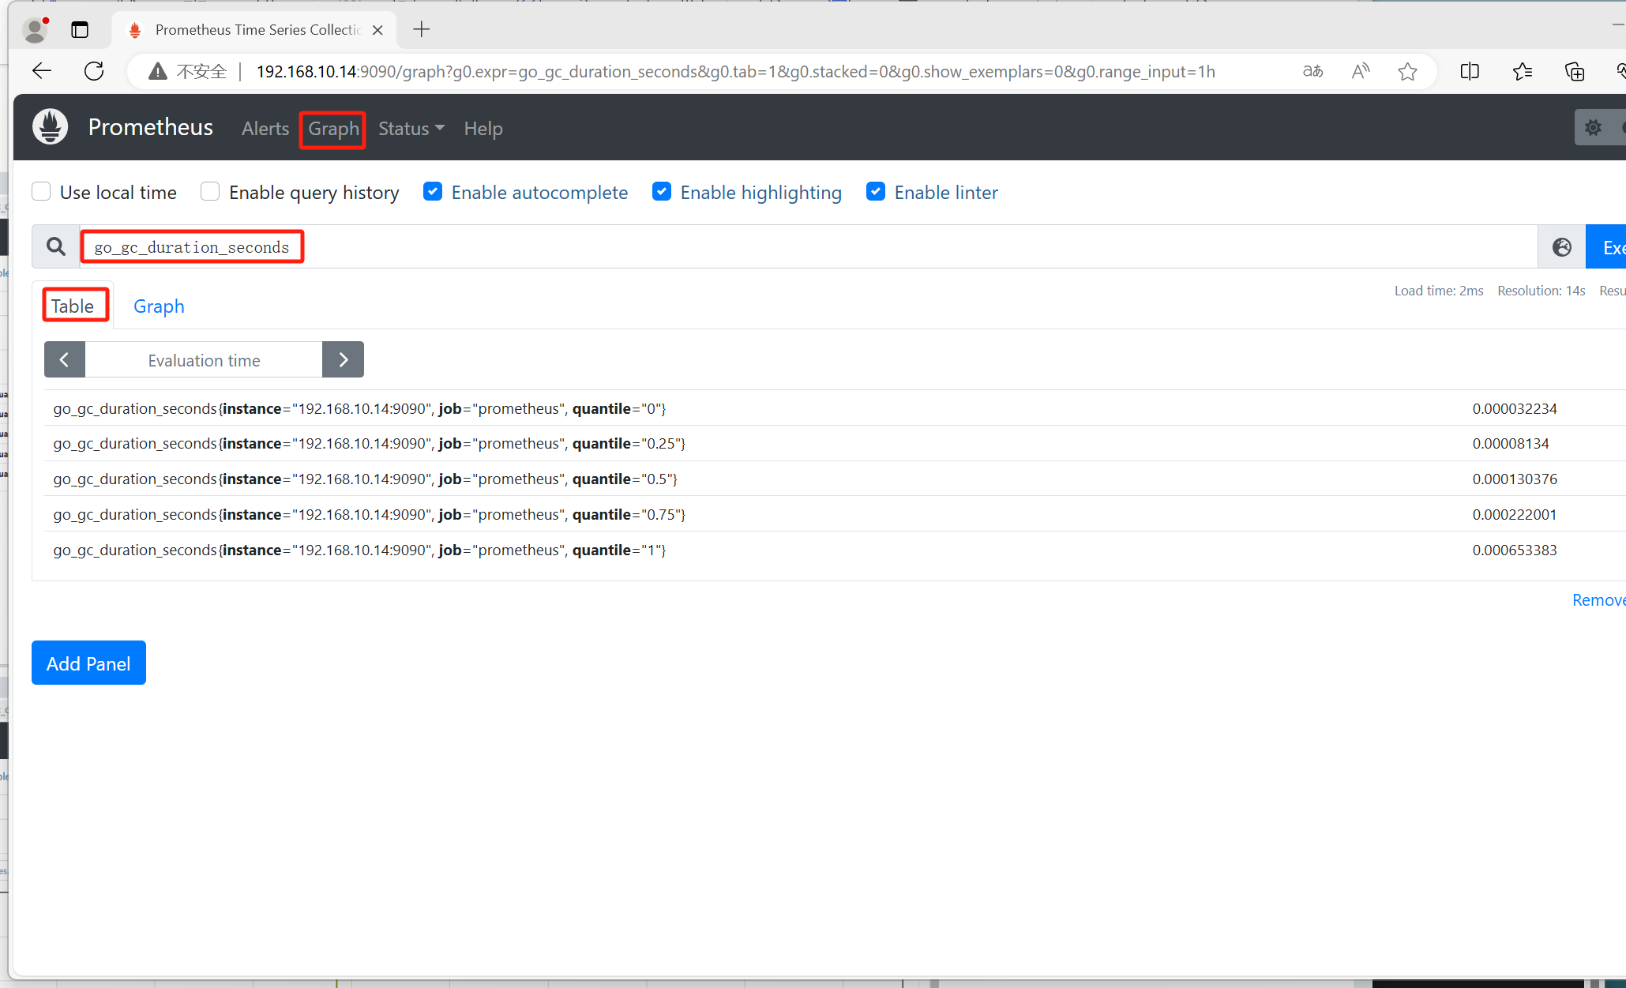

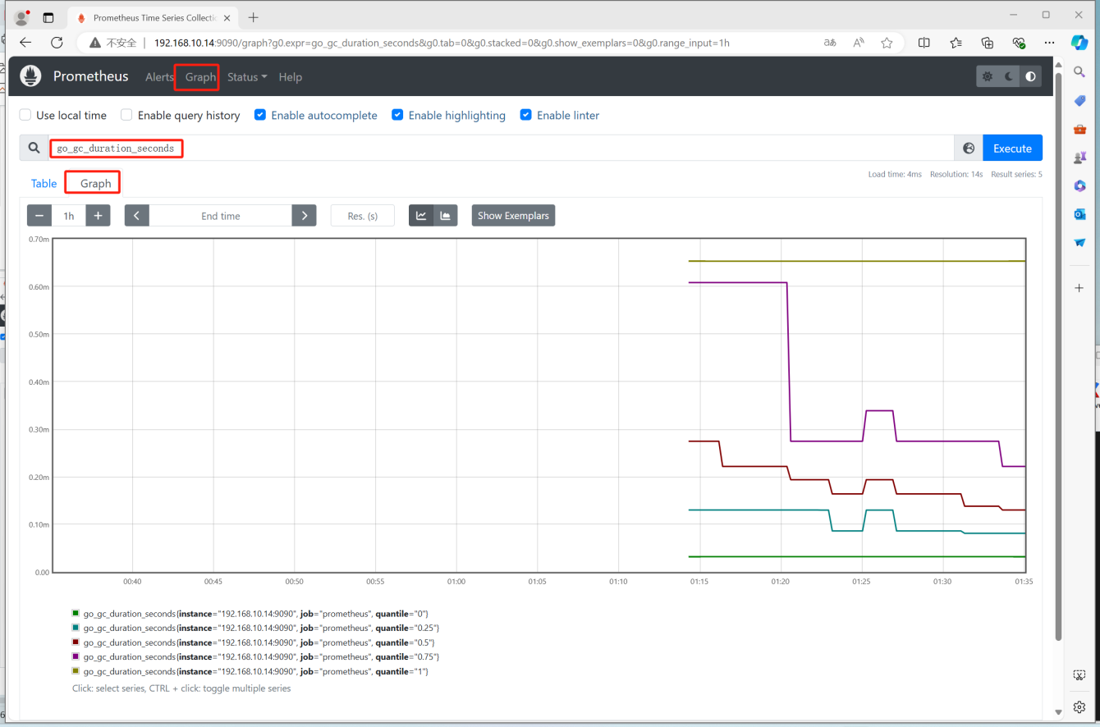

# 五、使用Prometheus监控Prometheus server及其它主机

## 5.1 对Prometheus server主机监控

### 5.1.1 下载node_exporter

[root@prometheus-server prometheus]# cd ~

[root@prometheus-server ~]# wget https://github.com/prometheus/node_exporter/releases/download/v1.6.0/node_exporter-1.6.0.linux-amd64.tar.gz

### 5.1.2 安装node_exporter

[root@prometheus-server ~]# tar xf node_exporter-1.6.0.linux-amd64.tar.gz  
  
[root@prometheus-server ~]# ls  
node_exporter-1.6.0.linux-amd64  
  
[root@prometheus-server ~]# mv node_exporter-1.6.0.linux-amd64 /usr/local/node_exporter  
  
[root@prometheus-server ~]# cd /usr/local/node_exporter/  
  
[root@prometheus-server node_exporter]# ls  
LICENSE node_exporter NOTICE

### 5.1.3 启动node_exporter

[root@prometheus-server node_exporter]# nohup ./node_exporter &

[root@prometheus-server node_exporter]# ss -anput | grep "node_exporter"  
tcp LISTEN 0 4096 [::]:9100 [::]:* users:(("node_exporter",pid=88088,fd=3))

[root@prometheus-server node_exporter]# ss -anput | grep ":9100"  
tcp LISTEN 0 4096 [::]:9100 [::]:* users:(("node_exporter",pid=88088,fd=3))

可以注册为systemd管理的系统服务

[root@prometheus-server node_exporter]# pkill node_exporter

注册为系统服务  
[root@prometheus-server node_exporter]# cat > /usr/lib/systemd/system/node_exporter.service << EOF  
[Service]  
ExecStart=/usr/local/node_exporter/node_exporter  
   
[Install]  
WantedBy=multi-user.target  
   
[Unit]  
Description=node_exporter  
After=network.target  
EOF

重载/开机自启/查看状态/启动  
[root@prometheus-server node_exporter]# systemctl daemon-reload  
[root@prometheus-server node_exporter]# systemctl enable node_exporter  
[root@prometheus-server node_exporter]# systemctl start node_exporter

[root@prometheus-server node_exporter]# systemctl status node_exporter

### 5.1.4 修改Prometheus Server配置文件添加node节点

[root@prometheus-server node_exporter]# cd /usr/local/prometheus/  
[root@prometheus-server prometheus]# ls  
console_libraries consoles data LICENSE NOTICE prometheus prometheus.yml promtool  
[root@prometheus-server prometheus]# vim prometheus.yml  
[root@prometheus-server prometheus]# cat prometheus.yml  
 。。。

scrape_configs:  
 # The job name is added as a label `job=<job_name>` to any timeseries scraped from this config.  
 - job_name: "prometheus"  
  
 # metrics_path defaults to '/metrics'  
 # scheme defaults to 'http'.  
  
 static_configs:  
 - targets: ["192.168.10.14:9090"]  
   
 添加node节点监控配置  
 - job_name: "prometheus-server"  
 static_configs:  
 - targets: ["192.168.10.14:9100"]

[root@prometheus-server prometheus]# systemctl restart prometheus

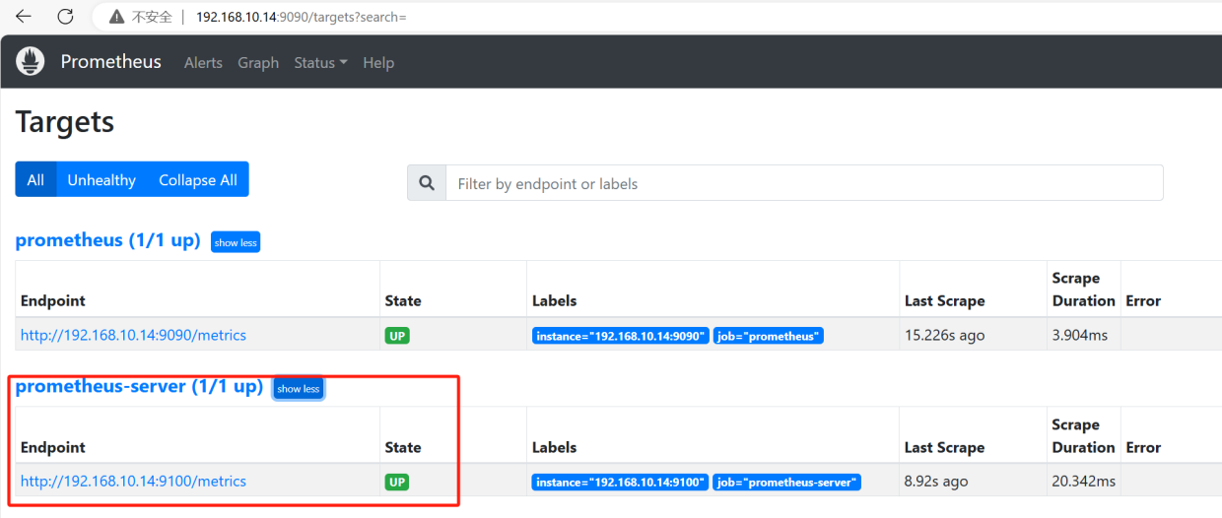

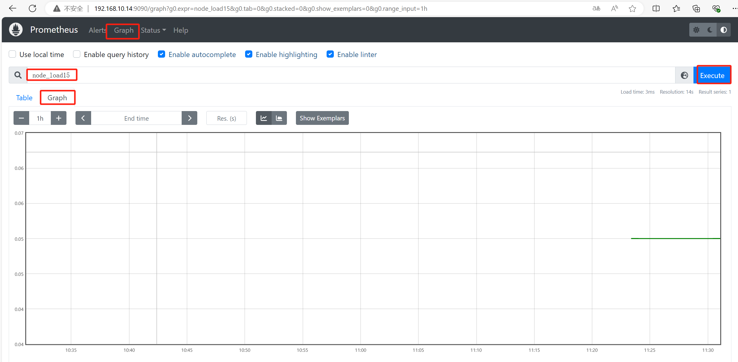

## 5.2 对其它主机进行监控

### 5.1.2 安装node_exporter

[root@prometheus-agent ~]# tar xf node_exporter-1.6.0.linux-amd64.tar.gz  
  
[root@prometheus-agent ~]# ls  
node_exporter-1.6.0.linux-amd64  
  
[root@prometheus-agent ~]# mv node_exporter-1.6.0.linux-amd64 /usr/local/node_exporter  
  
[root@prometheus-agent ~]# cd /usr/local/node_exporter/  
  
[root@prometheus-agent node_exporter]# ls  
LICENSE node_exporter NOTICE

### 5.1.3 启动node_exporter

[root@prometheus-agent node_exporter]# nohup ./node_exporter &

[root@prometheus-agent node_exporter]# ss -anput | grep "node_exporter"  
tcp LISTEN 0 4096 [::]:9100 [::]:* users:(("node_exporter",pid=88088,fd=3))

也可以注册为systemd服务，便于管理

[root@prometheus-agent node_exporter]# pkill node_exporter

注册为系统服务  
[root@prometheus-agent node_exporter]# cat > /usr/lib/systemd/system/node_exporter.service << EOF  
[Service]  
ExecStart=/usr/local/node_exporter/node_exporter  
   
[Install]  
WantedBy=multi-user.target  
   
[Unit]  
Description=node_exporter  
After=network.target  
EOF

重载/开机自启/查看状态/启动  
[root@prometheus-agent node_exporter]# systemctl daemon-reload  
[root@prometheus-agent node_exporter]# systemctl enable node_exporter

[root@prometheus-agent node_exporter]# systemctl start node_exporter

[root@prometheus-agent node_exporter]# systemctl status node_exporter

### 5.1.4 修改Prometheus Server配置文件添加node节点

[root@prometheus-server node_exporter]# cd /usr/local/prometheus/  
[root@prometheus-server prometheus]# ls  
console_libraries consoles data LICENSE NOTICE prometheus prometheus.yml promtool  
[root@prometheus-server prometheus]# vim prometheus.yml  
[root@prometheus-server prometheus]# cat prometheus.yml  
 。。。

scrape_configs:  
 # The job name is added as a label `job=<job_name>` to any timeseries scraped from this config.  
 - job_name: "prometheus"  
  
 # metrics_path defaults to '/metrics'  
 # scheme defaults to 'http'.  
  
 static_configs:  
 - targets: ["192.168.10.14:9090"]  
   
 添加node节点监控配置  
 - job_name: "prometheus-server"  
 static_configs:  
 - targets: ["192.168.10.14:9100"]  
 添加node节点监控配置  
 - job_name: "prometheus-agent"  
 static_configs:  
 - targets: ["192.168.10.15:9100"]

[root@prometheus-server prometheus]# systemctl restart prometheus

